RUSH WEEK REPORT FORM
Return to Pam Lamb, plamb@ksde.org by February 19

Chapter Name

School Name

Adviser Name Adviser Email

Names of Newly Affiliated Members: (Need 5 to qualify for prize money and more names can be added!)

1.
2.
3.
4.
5.
6.
7.
8.
9.
10.

All entries with a minimum of 5 newly affiliated members will be entered into a drawing for $50 at SLC. The chapter with the most new affiliations will be awarded $100 at State Leadership Conference.
*New chapters are eligible to be placed in the drawing. Brief Description of Community Service Project:
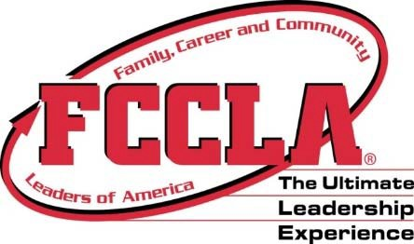

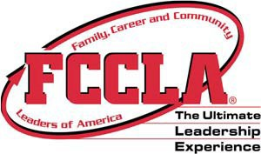
Rush Week
September 21-25, 2020 *
Goals of Rush Week:
- Increase membership by 5 members. This focuses on adding at least one new member each day of rush week.
- Promote your program throughout your school and community.
- Complete one community service project during rush week.
- Report via e‐mail the successes of the week utilizing the rush week form by February 19. E‐mail to Pam Lamb, plamb@ksde.org
- Participating schools will be entered in a drawing to win $50.00 at State Leadership Conference. New chapters are eligible for the drawing.
- The school with the most new affiliations will be awarded $100.00 at State Leadership Conference.
- * Above week is suggested - you may pick another week.
- Suggestions below or create your own – can use State or National theme for ideas.
Monday: Membership Poster Contest
- Hold a “Design a Poster Contest” ‐ post to attract new members. Give a prize to the winner – free membership, etc.
- Pass out cards to join that includes ‘jungle/zoo’ candy – “Get Wild About FCCLA!"
- Use jungle or zoo candy, etc. to create sayings
Tuesday: Be visual
- Set up a table near the main entrance or lunchroom to promote/collect dues
Wednesday: “Be Wild About FCCLA”
- Dress jungle/safari style, etc.
- Have a “Jungle Party”!
Thursday: “Go for the Red” day
- Wear Red/FCCLA attire – pass out notes or attach to lockers –
- Use the state or national theme – Wild About FCCLA or Beyond Measure.
- **Individual members who recruit 3 or more receive t‐shirt from
Nationals if complete application
Friday: Buddy Campaign
- Sign up a “Buddy Campaign”. All past/current members get one new person to join and receive a discount or prize

