RUSH WEEK REPORT FORM
Return to Pam Lamb, plamb@ksde.org by February 19

Chapter Name

School Name

Adviser Name Adviser Email

Names of Newly Affiliated Members: (Need 5 to qualify for prize money and more names can be added!)

1.
2.
3.
4.
5.
6.
7.
8.
9.
10.

All entries with a minimum of 5 newly affiliated members will be entered into a drawing for $50 at SLC.
(Includes new chapters)
The chapter with the most new affiliations will be awarded $50 at State Leadership Conference.
(2020 affiliated chapters only)

Brief Description of Community Service Project:
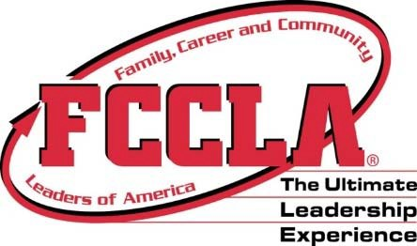

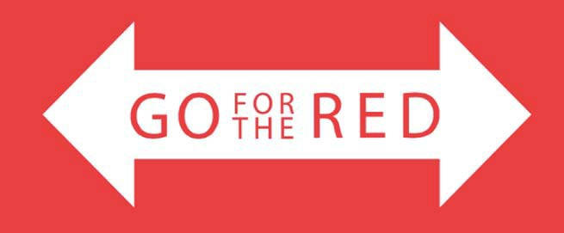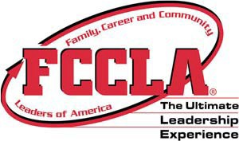
Rush Week
*September 20-24, 2021
Goals of Rush Week:
- Increase membership by 5 members. This focuses on adding at least one new member each day of rush week.
- Promote your program throughout your school and community.
- Use your officer team to create ideas!
- Complete one community service project during rush week.
- Report via e‐mail the successes of the week utilizing the rush week form by February 19. E‐mail to Pam Lamb, plamb@ksde.org
- Participating schools will be entered in a drawing to win $50.00 at State Leadership Conference. New chapters are eligible for the drawing.
- The school with the most new affiliations will be awarded $50.00 at State Leadership Conference. (2020 affiliated chapters only)
- * Above week is only a suggestion - you may pick any week.
- Suggestions below or create your own – can use State or National theme for ideas.
----------------------------------------------------------------------------------------------------------
Monday: “Be Out of this World!”
- Member Kick-off night/Membership Madness. Hold a membership party and include drawings for free membership, gift cards, etc.
- Pass out cards to join that includes ‘space’ candy – “Up and Away FCCLA!"
(Moon pies, Pop Rocks, etc.)
Tuesday: “Shoot for the Moon”
- Set up a table near the main entrance or lunchroom to promote/collect dues
- Use space items/candy to create sayings – lockers, entering front door . . .
- Be visual
Wednesday: “Launch Party”
- Have a “Space Party”!
- Have a “Buddy Campaign”. All past/current members get one new person to join and receive a discount or prize.
- Community Service Project – stadium clean-up, park clean-up, State Community Service Project – promote positive mental health
Thursday: “Go for the Red” day
- Wear Red/FCCLA attire – pass out notes or attach to lockers –
- Use the state or national theme for planning activities
Up and Away with FCCLA or Make it Count
- **Individual members who recruit 3 or more receive FCCLA t‐shirt
Friday: “Go Beyond!” – promote big at the end of the week!

