What: When: Where: Who:

Why:
Register Online by May 3, 2021

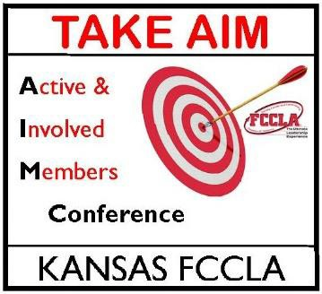
Kansas FCCLA Take AIM Conference August 29-30, 2021
Hilton Garden Inn, Manhattan

Kansas FCCLA Members, Officers and Chapter Advisers
Peer Education Teams and State Officers want you to be the best FCCLA member you can be!
During this power-packed event, members/officers will be prepared to:
- Be Actively Involved Members and officers

Learn leadership skills and how to use them
- Understand how to incorporate National Programs into everyday life
- Recognize appropriate Social Networking
- Acquire STAR Event information

MEMBER SESSIONS:
Sunday Night:
Leadership & Entertainment

Monday:
Breakouts & Tours

ADVISER SESSIONS:
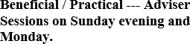
Pam Lamb, Kansas FCCLA State Adviser (785) 296-2164 or plamb@ksde.org

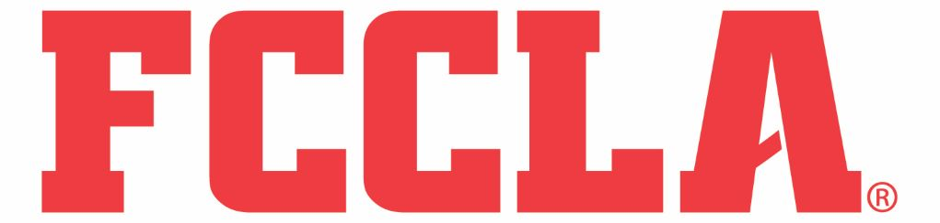
Sunday, August 29, 2021

1:00 - 3:00 pm District Presidents’ meeting
Peer Education Team Meeting State Officers’ meeting
3:00 - 5:00 pm District meetings (optional) 3:00 - 5:00 pm Registration
Take AIM Conference!
State Officers’ meeting
5:30 - 6:15 pm DINNER provided for peer
education members, state officers and district presidents
6:30-8:30 pm Leadership & Entertainment

8:30 – 10:30 pm TBD

Monday, August 30, 2021
7:30 - 9:00 am BREAKFAST- 2 shifts
9:00 - 3:00 Sessions

LUNCH - 2 shifts
3:00 Dismiss

Registration: $50
(includes 2 meals)
Lodging: $99/room + tax

Be a Complete FCCLA Member/Officer!

