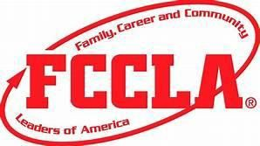
State Community Service Project Recognition Form
(due February 19)

Pick Me Up
Your chapter members can participate individually, in groups, or as a whole for this project to gain recognition.
Award Requirements:

Gold- 40 or more combined hours of community Service among your chapter 90% of your members are involved
Silver- 25-40 combined hours of Community Service among your chapter 70% of your members are involved
Bronze- 15-25 combined hours of Community Service among your chapter 50% of your members are involved
List of Community Service completed (may attach list)

Project # Members Involved Hours

________________________________________________________________________________________________________________________________________________________________________________________________________________________________________________________________________________________________________________________________________________________________________________________________________________________________________________________________________________________________________________________________________________________________________________________________________________________________

Chapter Name: __________________________________
Number of Members in your Chapter:
Chapter President Signature: ________________________
Adviser Signature: ________________________

