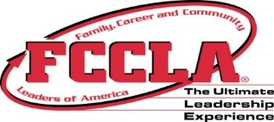

New and Nearly New FCCLA Adviser Workshop

Membership, Affiliation, Officers, Meetings, Organization, National Programs, STAR Events, Fundraising. . .

September 25, 2019
9:30 – 3:00
Cost: $25 – includes lunch & snacks

Register online by: September 5, 2019
Check, Credit Card or Purchase Order to KS FCCLA

