Questions for Professional Reflection on
Reader and Task Considerations

Cognitive Capabilities
- Does the reader possess the necessary attention to read and comprehend this specific text?
- Will the reader be able to remember and make connections among the various details presented in this specific text?
- Does the reader possess the necessary critical/analytic thinking skills to understand the relationships between the main idea, purpose, and/or theme of the text and the various details used to support that main idea, purpose, and/or theme?
- Will this specific text help to develop the attention, memory, and critical/analytic thinking skills necessary for future reading endeavors?

Reading Skills
- Does the reader possess the necessary inferencing skills to “read between the lines” and make connections among elements that may not be explicit in this specific text?
- Does the reader possess the necessary visualization skills to imagine what is occurring or what is being described in this specific text?
- Does the reader possess the necessary questioning skills to challenge the ideas being presented in this text and consider those ideas from multiple points of view?
- Does the reader possess the necessary comprehension strategies to manage the material in this specific text?
- Will this specific text help to develop the inferencing skills, visualization skills, questioning skills, and comprehension strategies necessary for future reading endeavors?

Motivation and Engagement with Task and Text
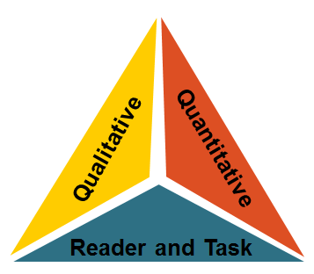
- Will the reader understand the purpose—which might shift over the course of the reading experience—for reading this specific text (i.e., skimming, studying to retain content, close reading for analysis, etc.)?
- Will the reader be interested in the content of this specific text?
Questions for Professional Reflection on
Reader and Task Considerations

- Might the reader develop an interest in this content because of this text?
- Will the reader be interested and engaged with the style of writing and the presentation of ideas within this specific text?
- Will the text maintain the reader’s motivation and engagement throughout the reading experience?

Prior Knowledge and Experience
- Does the reader possess adequate prior knowledge and/or experience regarding the topic of this specific text to manage the material that is presented?
- Are there any explicit connections that can be made between what content the reader will encounter in this specific text and other learning that may occur in this or another class?
- Does the reader possess adequate prior knowledge and/or experience regarding the vocabulary used within this specific text to manage the material that is presented?
- Does the reader possess adequate knowledge of and/or experience with the genre of this specific text to manage the material that is presented?

Content and/or Theme Concerns
- Are there any potentially concerning elements of content or theme that might contribute to students, teachers, administrators, and/or parents feeling uncomfortable with reading this specific text?
- Does the reader possess the maturity to respond appropriately to any potentially concerning elements of content or theme?

Complexity of Associated Tasks
- Will the complexity of any before-, during-, or after-reading tasks associated with this specific text interfere with the reading experience?
- Will the complexity of any questions asked or discussed concerning this text interfere with the reading experience?

