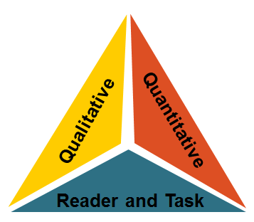

Book Title: ______________________________
Qualitative Measures

Levels/Layers of Meaning:

Ambiguity of theme(s):

Structure:

Narration POV Shifts:

Order of Events:

Use of graphics:

Language Conventionality and Clarity:

Abstract &/or fig. lang:

Vocab Archaic or Tier3:

Sentence Structure –phrasing:

Knowledge Demands:

Life experiences relatable to student:

Culture/Prior content knowledge needed:

Book Title: ______________________
Qualitative Measures

Levels/Layers of Meaning:

Ambiguity of theme(s):

Structure:

Narration POV Shifts:

Order of Events:

Use of graphics:

Language Conventionality and Clarity:

Abstract &/or fig. lang:

Vocab Archaic or Tier3:

Sentence Structure –phrasing:

Knowledge Demands:

Life experiences relatable to student:

Culture/Prior content knowledge needed:

Quantitative Measures

Reader-Task Considerations

Recommended Placement

Quantitative Measures

Reader-Task Considerations

Recommended Placement

