Qualitative Measures

Levels of Meaning:
The novel has a single level of meaning: a contemporary girl’s struggles with a moral dilemma to solve economic hardship and family troubles.

Structure:
A simple structure told by a single narrator with events in chronological order. The novel does employ foreshadowing but flashbacks are not used.

Language Conventionality and Clarity:
Simple figurative language and imagery is used. The voice of the narrator is conversational, familiar, and contemporary.

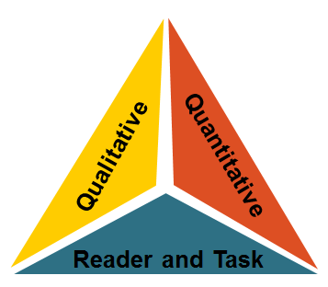
Knowledge Demands:
Themes include poverty, family relationships, and moral dilemma. Events of the novel are everyday experiences common to our contemporary world.
Quantitative Measures
Qualitative Measures

Various readability measures of How to Steal a Dog are largely in agreement that is of appropriate complexity for grades 4-7. The ATOS formula (used with the Accelerated Reader program) identifies this title as having a book level of 4.0 . A Lexile measure for this novel is 700L .

Reader-Task Considerations

These are to be determined locally with reference to such variables as a student’s motivation, knowledge, and experiences as well as purpose and the complexity of the task assigned and the question posed.
Here in Kansas, educators might want to examine the following elements or issues: the ethics of stealing, the consequences of poverty, and the creation of personal standards of behavior.

Recommended Placement

How to Steal a Dog is a 2010 William Allen White winner. Both the qualitative and quantitative measures support the novel’s placement in the grades 4-5 text complexity band. This book also ties into financial literacy standard.

