Take AIM T-Shirt
Order Orders due: August 3, 2021

Chapter Name: ____________________________________
Adviser: ____________________________________

Size | Members/ Advisors | Peer Ed/State Officers/Dist.  Presidents | Cost | Sub Total
Small |  |  | $15
Medium |  |  | $15
Large |  |  | $15
XL |  |  | $15
2XL |  |  | $16
3XL |  |  | $17
4XL |  |  | $18
Total

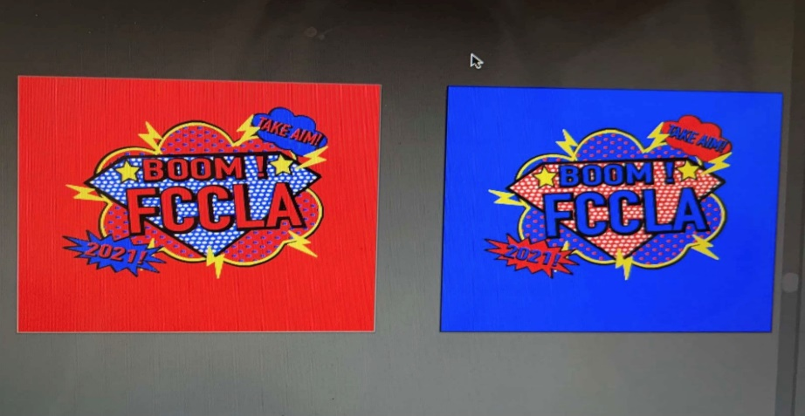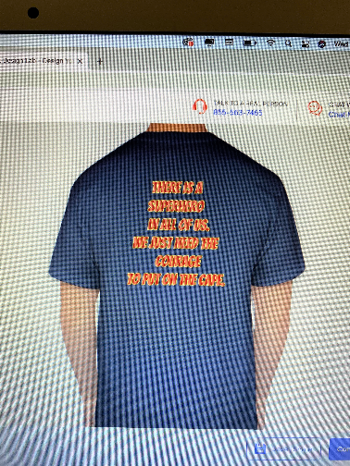
Members/Advisers
Peer Ed/State Officers/ District Presidents

There is a Superhero in all of us.
We just need the courage to put on the cape.

