Qualitative Measures

Levels of Meaning:
The book’s main metaphor compares the process of discovering the deep beauty in both the willow bark and also in our twelve-year-old main character, Willow. Something very precious can grow out of painful scars, as the skinned and polished stick shows. Not all middle school readers will understand this deeper-than-surface meaning. But the story will be very satisfying even without the understanding of the book’s main metaphor.

Structure:
Complex format. This book is mostly poems in diamond form, each with a hidden message written in bold type. Told in first-person fictional narrative. Dialogue is written in italics. Simple chronological order of events. Interspersed sporadically are the observations from Willow’s dead (& reincarnated) ancestors.
Language Conventionality and Clarity:
Language is conversational and familiar. Willow’s thoughts – frustration with authority, insecurity with peers – are universal. There are a few, but not many, domain-specific vocabulary words for this setting and culture, i.e. hypothermia.
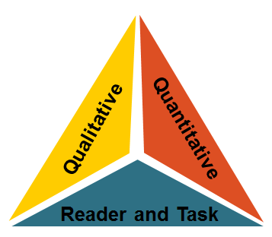
Knowledge Demands:
Willow’s grandparents represent the old Dinak’I ways in remote Alaska. Experiences (sled dogs) and beliefs (reincarnation) may be quite different from the average reader.
Quantitative Measures

Various readability measures of Diamond Willow are largely in agreement that this is of appropriate complexity for grades 5 - 8. The ATOS formula (used with the Accelerated Reader program) identifies this title as having a book level of 4.3 . A Lexile measure for this novel is 670L.
Reader-Task Considerations

These are to be determined locally with reference to such variables as a student’s motivation, knowledge, and experiences as well as purpose and the complexity of the task assigned and the question posed.
Here in Kansas, educators might want to examine the following elements or issues: motivating students of both genders to become comfortable with the unique poems.

Recommended Placement

Diamond Willow is on the William Allen White 2010-2011 nominated list (6th- 8th-grade) for the state of Kansas. The book is also on many other state award lists. The author is a Michael Printz Honor winner for a previous book.

