Qualitative Measures

Levels of Meaning: There are multiple levels of meaning: Many symbolic objects regarding the concept of family and of place. The conversations that Abilene has with Miss Sadie and Shady, plus the newspaper articles of Miss Hattie, are filled with symbols and allusions. Abilene’s “universals” are subtle meanings of our patterns. Her insights on life are universally meaningful, i.e. on. p. 144. “Maybe the world wasn’t made up of universals that could be summed up in neat little packages. Maybe there were just people. People who were tired and hurt and lonely and kind in their own way and their own time.”
Structure: Moderately complicated narrative structure, with occasional shifts in time and shifts in point of view. There are parallel stories of Manifest, Kansas 1936 and Manifest, Kansas 1918. The 1936 story is the main one and is told in first-person narrative by 12-year-old Abilene Tucker.
Language Conventionality and Clarity: Largely explicit and literal meaning of the language with some subtle use of figurative language expressions. Words from the setting-specific are rare but do exist, i.e. “speak-easy” and “divining”.
Nothing too unfamiliar or archaic for a 6th-10th-grader.
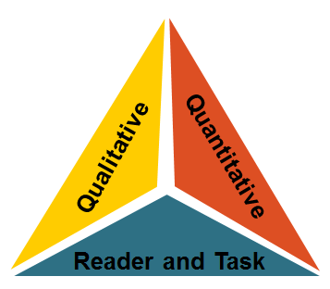
Knowledge Demands: Multiple themes; experience is uncommon to most readers; allusions to Moby Dick by Herman Melville.
Quantitative Measures
Qualitative Measures

Various readability measures of Moon Over Manifest are largely in agreement that is of appropriate complexity for grades 6-10. The ATOS formula (used with the Accelerated Reader program) identifies this title as having a book level of 5.3. A Lexile measure for this novel is 800L .
Reader-Task Considerations

Here in Kansas, educators might find that students will be very motivated to read this book because it is set in our state, and the award-winning author lives in Wichita. The history and culture of SE Kansas comes to life.

Recommended Placement

Moon Over Manifest is the 2011 Newbery Award Winner. Both the qualitative and quantitative measures support the novel’s placement in the grades 6th-10th grade text complexity band. This book also ties into social studies and some science standards.

Analyzed by Bev Nye, bev.nye@mcpherson.com
McPherson Middle School, 3/12/11

