Qualitative Measures

Levels of Meaning:
The novel has a multiple levels of meaning. Literally, the story centers around Katniss, who lives in the not-too-distant future in the remains of what was once North America. As her home district’s representative to the annual Hunger games, she competes for survival. The book is also a social commentary on reality television and social issues.
Structure:
A simple structure told by a first person narrator with foreshadowing and flashback, the book does require the reader to picture a future world with event and customs that may be unfamiliar.
Language Conventionality and Clarity:
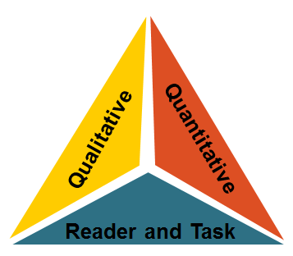
Vivid description, figurative language and imagery is used to help the reader picture this world in the not-too-distant future. The voice of the narrator is conversational, familiar, and contemporary.
Knowledge Demands:
Higher level themes of moral dilemma, social criticism, government control, war and hunger. Events of the novel are unique to Katniss’s world of the future and require a deeper level of thinking on the part of the reader.
Quantitative Measures
Qualitative Measures

Various readability measures of The Hunger Games are largely in agreement that is of appropriate complexity for grades 7-adult.. The ATOS formula (used with the Accelerated Reader program) identifies this title as having a book level of 5.3 . A Lexile measure for this novel is 810L .
Reader-Task Considerations

These are to be determined locally with reference to such variables as a student’s motivation, knowledge, and experiences as well as purpose and the complexity of the task assigned and the question posed.
Here in Kansas, educators might want to examine the following elements or issues: the consequences of hunger, people’s Constitutional rights, and links to other books such as 1984, The Giver, Fahrenheit 451, and others for student learning differentiation purposes.

Recommended Placement

The Hunger Games is the 2010 Heartland Award winner in Kansas. Both the qualitative and quantitative measures support the novel’s placement in the grades 7 and higher text complexity band. This book also ties into social studies and some science standards.

