Qualitative Measures

Levels of Meaning/Purpose:
With more than one level of meaning and considered a model coming-of-age novel, the male protagonist Gene Forrester is faced with the consequences of his actions that change both his life and best friend Finny. The emotions exhibited in this work span generations.

Structure:
Smooth sentence structure, syntax and flow are reasons why this book is a classic. Gene’s perspective as a tormented teen is interwoven with the reflection of Gene as an adult looking back at that fateful critical year which shaped his adult life. Flashback and flash forward elements are interwoven into the story.

Language Conventionality and Clarity:
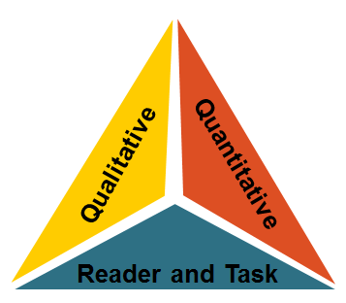
First published in 1959, the language is challenging and requires diligence by the student to follow.
Knowledge Demands:
Themes of war, rivalry, jealousy and growing up are interwoven into the story line. Abilities to contemplate and understand the complex issues presented are needed by the student for full study.

Quantitative Measures
Qualitative Measures

The ATOS formula identifies this title as having a book level of 6.9 while the Lexile measure is 1110L, placing this book at the 6th-8th grade text complexity band.

Reader-Task Considerations

Used in an Honor’s English II classroom, this book is read for multiple purposes: novel study as a form of literature, literary elements, figurative language, vocabulary study, and imagery. Over-arching year-long objectives include exploration of the themes of jealousy, rivalry, and growing up are interwoven into many of the curriculum plans.

Recommended Placement

Hailed as a literary masterpiece, A Separate Peace is a classic novel with numerous teaching resources available. When considering the qualitative measures and the reader-task considerations, this novel is well placed at the 9th-10th grade complexity band. The complex themes, use of first person narrative—but with multiple flash backs and flash forward indicate higher level reading skills are needed by the reader. The Common Core Standards Text Exemplars also place the novel in the 9th-10th grade complexity band.

