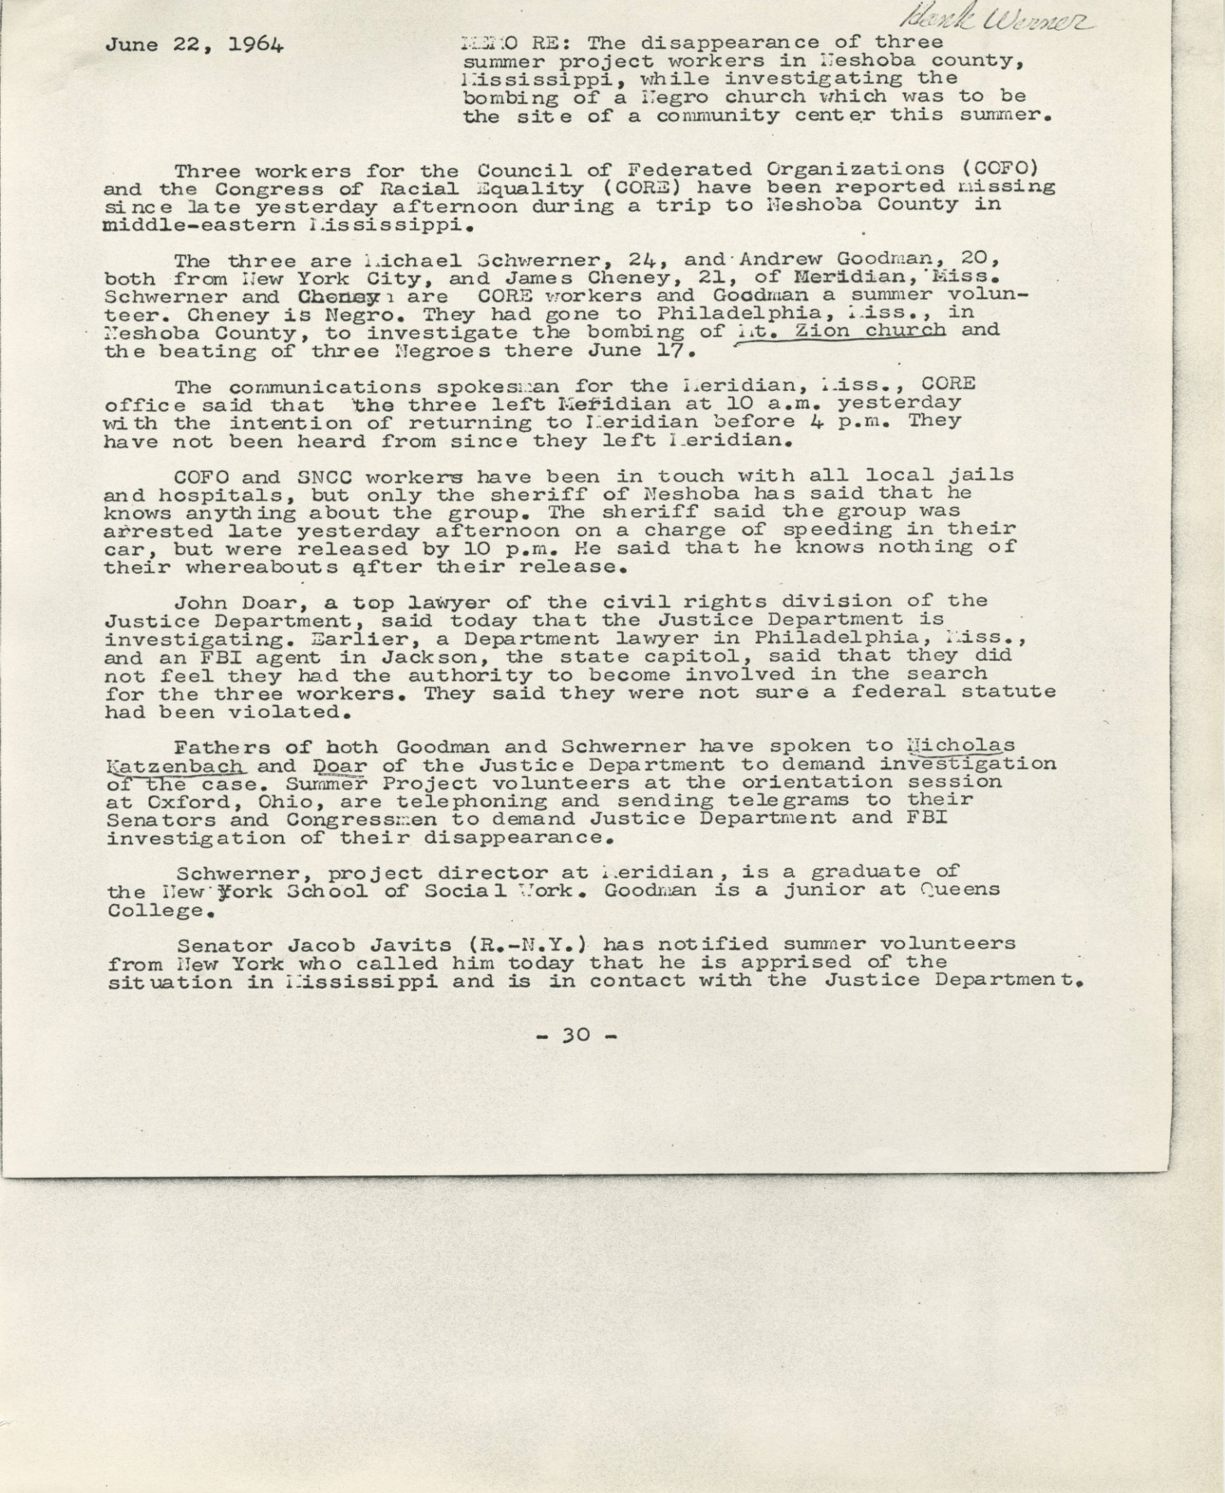
Memo from Bob Moses regarding the disappearance of 3 Freedom Summer Workers:
419 words.
Wisconsin Historical Society
http://content.wisconsinhistory.org/cdm/ref/collection/p15932coll2/id/2587

NEW YORK TIMES Article regarding the disappearance of 3 Freedom Summer Workers
(Complete information at New York Times On This Day at http://www.nytimes.com/learning/general/onthisday/big/0621.html#article
Mississippi Campaign Heads Fear Foul Play--Inquiry by F.B.I. Is Ordered

Three Men Reported Missing In Mississippi Rights Campaign

By CLAUDE SITTON

Special to The New York Times

Philadelphia, Miss., June 22--Three workers in a day-old civil rights campaign in Mississippi were reported missing today after their release from jail here last night.

Leaders of the drive said they feared that the three men--two whites, both from New York, and one Negro, had met with foul play.

The three had been held by Neshoba County authorities for four hours following the arrest of one on a speeding charge and the jailing of the others "for investigation."

Agents of the Federal Bureau of Investigation began arriving here in force early tonight after the Justice Department ordered a full-scale search.

The Mississippi Highway Patrol issued a missing-persons bulletin, but a spokesman in Jackson indicated late today that it had no plans at present for further action.

All three missing men arrived in Mississippi late Saturday afternoon from Oxford, Ohio, where they had taken part in a one-week orientation course for the statewide project. They were among the advance group of some 175 workers who are expected to be followed by another 800 participants in the campaign of political action, education and cultural activities among Negroes.

One of the missing whites is Michael Schwerner of Brooklyn, a 24-year-old former settlement-house worker. He came here six months ago with his wife, Rita, to open one of the first community centers for Negroes in Mississippi. Mrs. Schwerner remained at Oxford to take part in the second orientation course for volunteers.

The second missing man is Andrew Goodman, 20, a student volunteer from Queens.

The third is James E. Cheney, 21, a Meridian plasterer and driver of the late-model Ford station wagon in which they were last seen.

Both Mr. Schwerner and Mr. Cheney are members of a civil rights task force organized by the Congress of Racial Equality, which is cooperating with the Student Nonviolent Coordinating Committee and other organizations in the Mississippi project.

Concern over the fate of the three was heightened by the fact that the two CORE men had always reported their whereabouts before at frequents intervals, according to campaign spokesmen in Jackson. Workers in the Meridian drive headquarters said Mr. Schwerner had repeatedly emphasized the importance of this to the others during their drive here from Oxford.

Further, the prospect of the civil rights campaign had led to an increasing number of violent incidents even before the workers began arriving last Friday.

The three men left Meridian yesterday at about 9:30 A.M. for Philadelphia, about 35 miles away, where they planned to look into the burning of the Mount Zion Methodist Church last Tuesday night. The Negro church was in the Longdale community, some 12 miles east of this town of 5,500 persons in east-central Mississippi.

Cecil Price, the Neshoba County deputy sheriff, said he had halted and arrested the three about 5:30 P.M. yesterday. He said Mr. Cheney had been driving 65 miles an hour in a 30-mile zone on the outskirts of Philadelphia before he stopped them. The whites were held "for investigation."

The three were released from the county jail here at 10:30 P.M. after Mr. Cheney paid a $20 fine.

"I told them to leave the country," said Mr. Price. The three then drove out along State Highway 19 after having told the deputy they were returning to Meridian, according to him.

Sheriff L. A. Rainey, a burly, tobacco-chewing man, showed little concern over the report that the workers were missing.

"If they're missing, they just hid somewhere, trying to get a lot of publicity out of it, I figure," he said. i

Robert Weil, spokesman for the campagn headquarters in Jackson, said campaign leaders "definitely fear that there was foul play, perhaps by the local citizens after they were released."

F.B.I. Inquiry Ordered

Special to The New York Times

Washington, June 22--The Federal Bureau of Investigation has been ordered to make a full inquiry into the disappearance of the three civil rights volunteers.

Edwin O. Guthman, Justice Department spokesman, said:

"We are investigating the possibility that they are being held against their will by persons who are not law-enforcement officers or that they are otherwise being deprived of their civil liberties."

Mr. Guthman also said that the Department of Justice wanted to question the volunteers about the circumstances of their arrest and release.

Couple There Since January

Headquarters of the Congress of Racial Equality in New York City said yesterday that Michael Schwerner and his wife had been in Mississippi for CORE since last January. They were running a Community Center at Meridian where Negroes were trained for civil service examinations, voter registration and in other phases of the civil rights program.

Before joining CORE, Mr. Schwerner was a group worker at Hamilton-Madison House, a social center at 50 Madison Street on the Lower East Side of Manhattan. He and his wife lived at 364 Henry Street, in Brooklyn Heights.

Mr. Schwerner's parents live in Pelham, in Westchester County. He attended Cornell and Columbia.

Andrew Goodman is an anthropology student at Queens College and lived with his parents, Mr. and Mrs. Robert W. Goodman, at 161 West 86th Street. He had arrived at Meridian only 24 hours before starting out on the trip with Mr. Schwerner and James Cheney. He was one of the group of Northern volunteers who had been taking instruction at Oxford, Ohio.
Mrs. Goodman is a practicing psychologist and her husband is a civil engineer.

898 words.

