Resources for Accessing Quantitative Measures of Text

Lexile

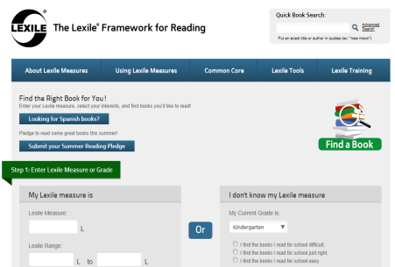
Find a Book
www.lexile.com/findabook/
Allows user to search for published books in the database by title, author, keywords, or ISBN to find a Lexile measure.

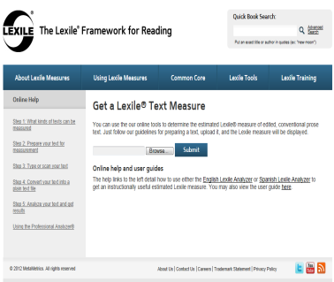
Lexile Analyzer

www.lexile.com/analyzer/

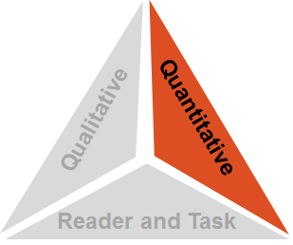
Allows user to receive an “estimated” Lexile measure for text not in the Find a Book database by copying and pasting text into the analyzer. Free registration is required. Accommodates texts up to 1000 words in length. Longer texts can be analyzed by upgrading to the Professional Lexile Analyzer—educators can upgrade to this tool for free by requesting access at the following URL: www.lexile.com/account/profile/access/

ATOS Book Level (Accelerated Reader)

AR BookFinder
www.arbookfind.com
Allows user to search for published books in the database by author, title, or topic to find a ATOS Book Level.

The ATOS Analyzer

www.renlearn.com/ar/overview/atos/

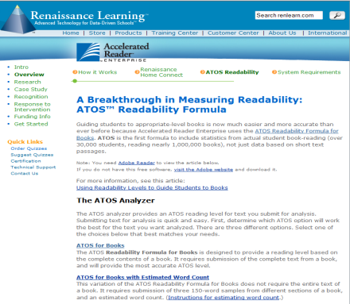
Allows user to receive an ATOS Book Level for text not in the AR BookFinder database by uploading an electronic file or copying and pasting text directly. No registration is required. User can submit full-text or three 150-word samples and an estimated full-text word count.

Additional Resources for Accessing Quantitative Measures of Text

Coh-Metrix Easability Tool. University of Memphis
Beta site available at: http://141.225.42.101/cohmetrixgates/Home.aspx?Login=1

Degrees of Reading Power: DRP Analyzer—Questar Assessment, Inc.
www.questarai.com (Contact info@questarai.com or 1-845-277-1600 with requests for DRP Text Analysis Services).

Pearson Reading Maturity—Pearson Knowledge Technologies
Beta site available at: www.readingmaturity.com

REAP—Carnegie Mellon University
www.reap.cs.cmu.edu/

SourceRater Educators Testing Service
Beta site available at: http://naeptba.ets.org/SourceRater3/

Readability Formulas
The Flesch Reading Ease Readability Formula
Readability Ease = 206.835 – (1.015 x average sentence length) – (84.6 x average syllable per word).
The higher the number, the easier the passage: 90-100, very easy and 0-29, very confusing.
The Flesch-Kincaid Grade Level Readability Formula
Flesch-Kincaid Reading Age = (0.39 x average sentence length) + (11.8 x average syllable per word) - 15.59
The score is given as a grade level equivalent – a score of 9.4 would be 9th grade. Flesch-Kincaid Grade Level Readability Formula is built into the MS-Word application.
Gunning’s Fog Index (or FOG) Readability Formula
The FOG formula takes into consideration (1) the total number of words, (2) the number of words of three or more syllables, and (3) the total number of sentences.
Grade Level = 0.4 (Average Sentence Length + Percentage of Hard Words).
Hard words are defined as words with three or more syllables.
The Dale-Chall Readability Formula
Raw Score = 0.1579 Percentage of Difficult Words + 0.0496 Average Sentence Length in words + 3.6365
Raw scores convert to grade levels with scores 5.0 to 5.9 = Grades 5 – 6 and 8.0 to 8.9 = Grades 11 - 12
Difficult words are words that do not appear on the Chall word list of over 3000 familiar words.

