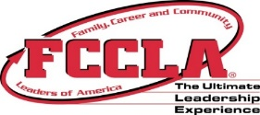 2018-2019 Calendar 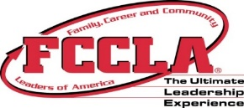
(Updated 10/26/18)

December SEAC
December 5-6, 2018 – Hesston

2018 District Fall Conferences
District A – Oct. 31 District EE – Oct. 18 District H – Oct. 24
District B – Oct. 3 District EW – Oct. 3 District I – Oct 30
District C – Nov. 8 District F – Oct. 24 District JE – Oct. 23
District D – Nov. 7 District G – Oct. 16 District JW – Oct. 17

FCS Career Days:
KSU Wild about FCS: October 5, 2018 PSU FCS Career Day: October 16, 2018

State Board of Directors
January 15, 2019 – Topeka
.
National Cluster Meetings
November 9-11, 2018 – Louisville, KY November 16-18, 2018 – Phoenix, AZ

State & National Affiliation: December 15, 2018

Citizenship Day: January 16, 2019 – Topeka

National FCCLA Week: February 10-16, 2019

ALL Recognition Applications due: February 19, 2019

FCCLA/FCS Day on the Hill: February 20, 2019

2019 District Elections/STAR Events
District A – Jan. 30/Feb. 13 District EE – Feb. 14 District H – Feb. 6
District B – Jan. 30/Feb. 14 District EW – Feb. 6 District I – Feb. 15
District C – Feb. 7 District F – Jan. 16/Jan. 30 District JE – Feb.6/Jan. 30
District D – Feb. 13/Feb. 6 District G – Feb. 6 District JW – Feb. 6

State Leadership Conference & STAR Events
April 7-9, 2019: Wichita
April 5-7, 2020: Wichita
April 11-13, 2021: Wichita

National Leadership Conference
June 30 – July 4, 2019: Anaheim, CA
July 5-9, 2020: Washington DC
July 4-8, 2021: Nashville, TN

